Week 1 – Semester 8th

Progress on the Turtlebot

- SLAM
Did not work on SLAM as it already works fine

- VOICE
- We worked on the Kinect configuration with the PC, with has a lot of issues – errors attached below
- Errors in Kinect resolved : - It needs 12v to work. Our circuit gives 8v on no load- open loop.

- Installed alsa drivers

- Created the code for recording the sound
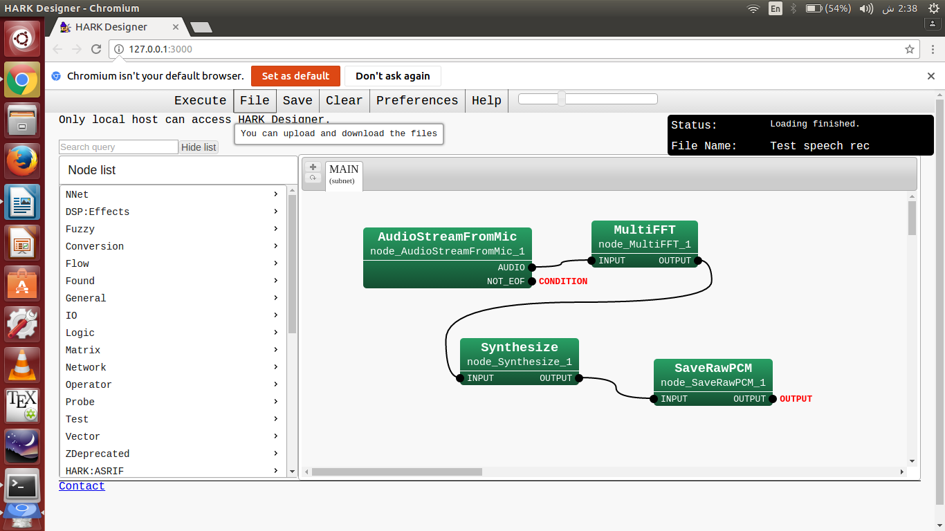

- FACE
No progress this week

- HARDWARE

- OBJECT MANIPULATOR
- We read papers on object manipulation, rough Literature review prepared

- Searched for the right software, compatible with ROS and with the ArbotiX controller

- Installed arduino 1.0.6 which is the only one that ArbotiX works on

- The connections of the arm are such that every joint has an input and out put port where the 4pin connections is given; every preceding motor gives the feedback (output) to next motor's input. The base joint is given to to the ArbotiX chip and FTDI cable is also connected to it, that is then connected to the computer.

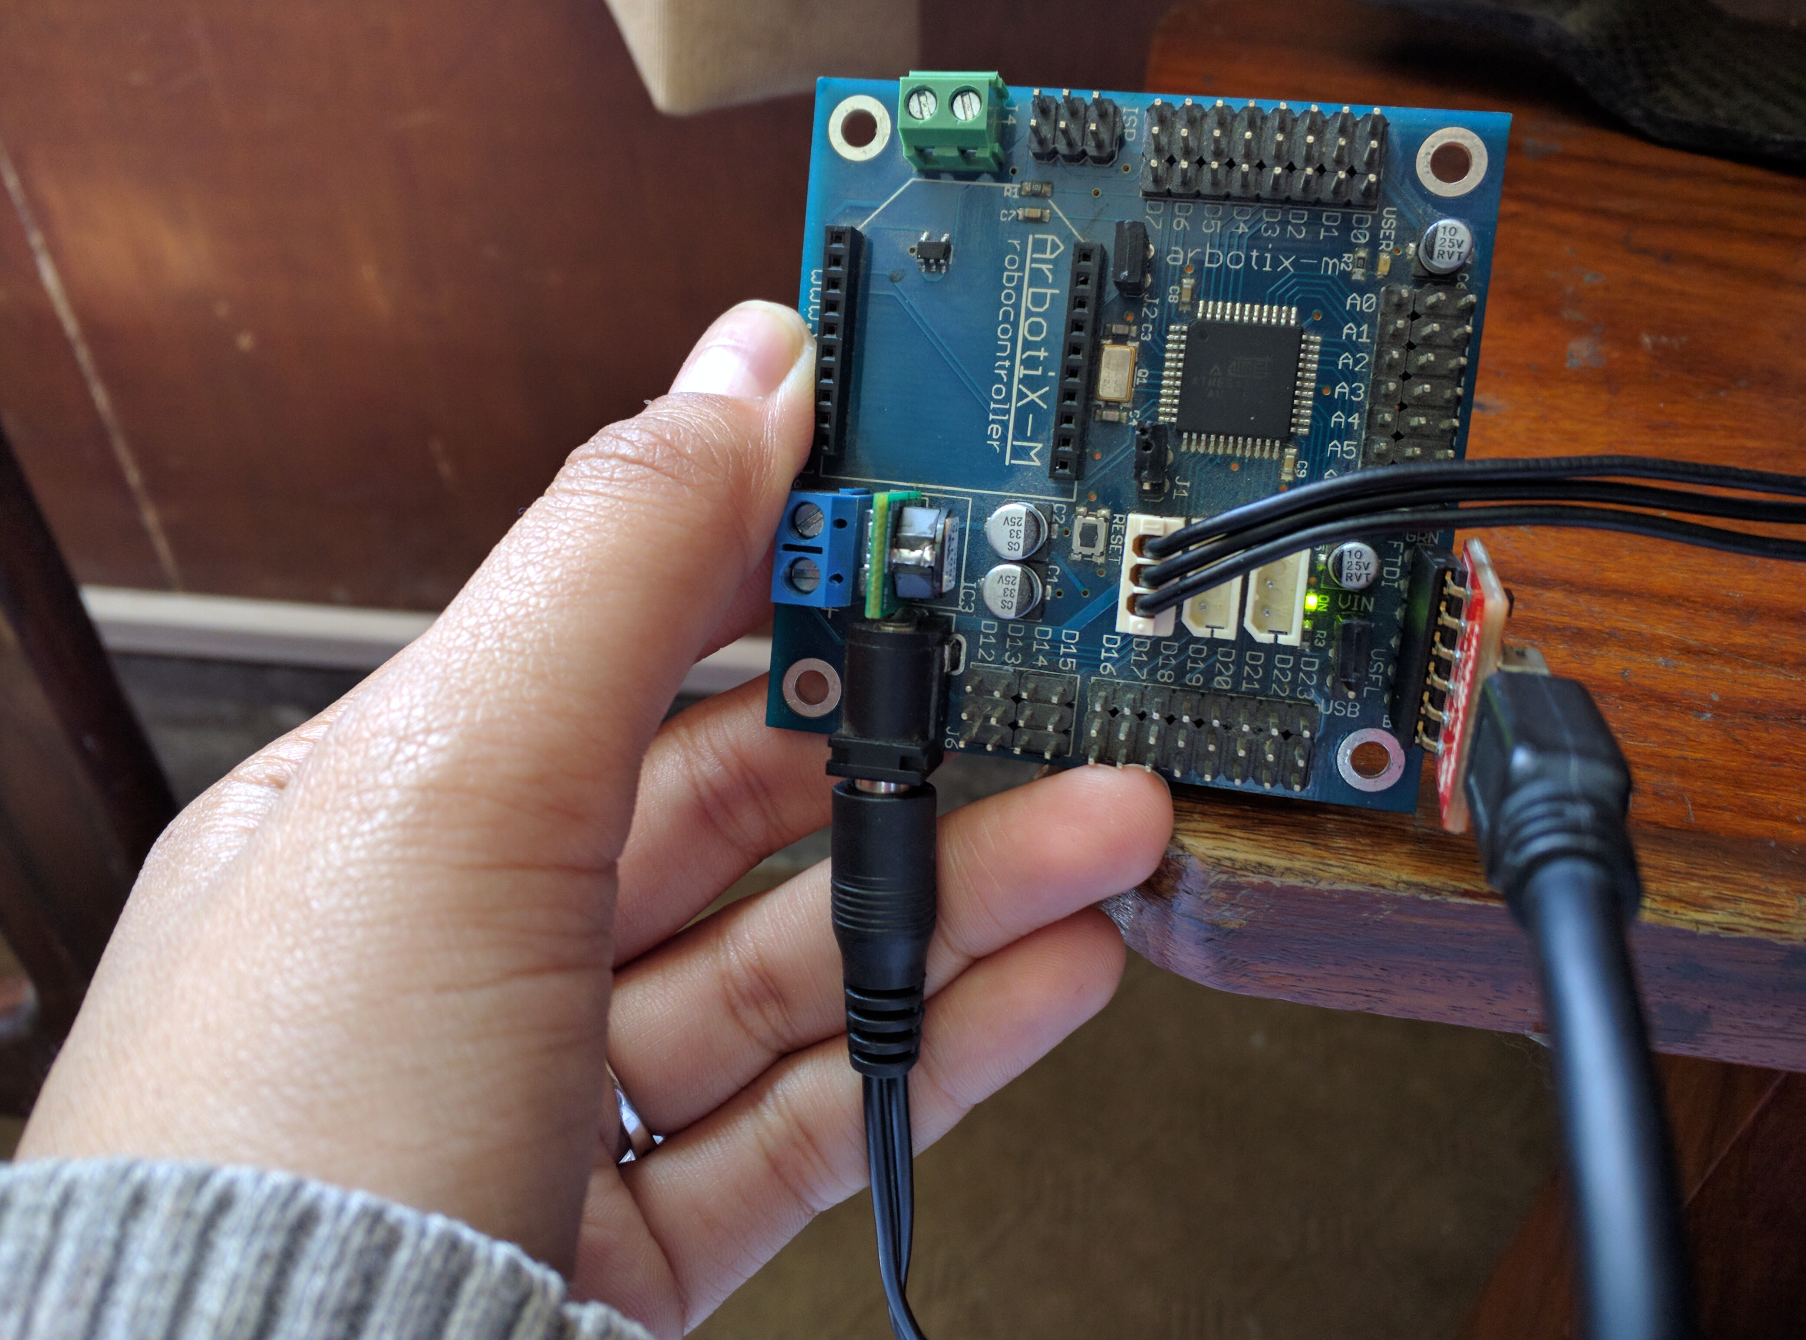
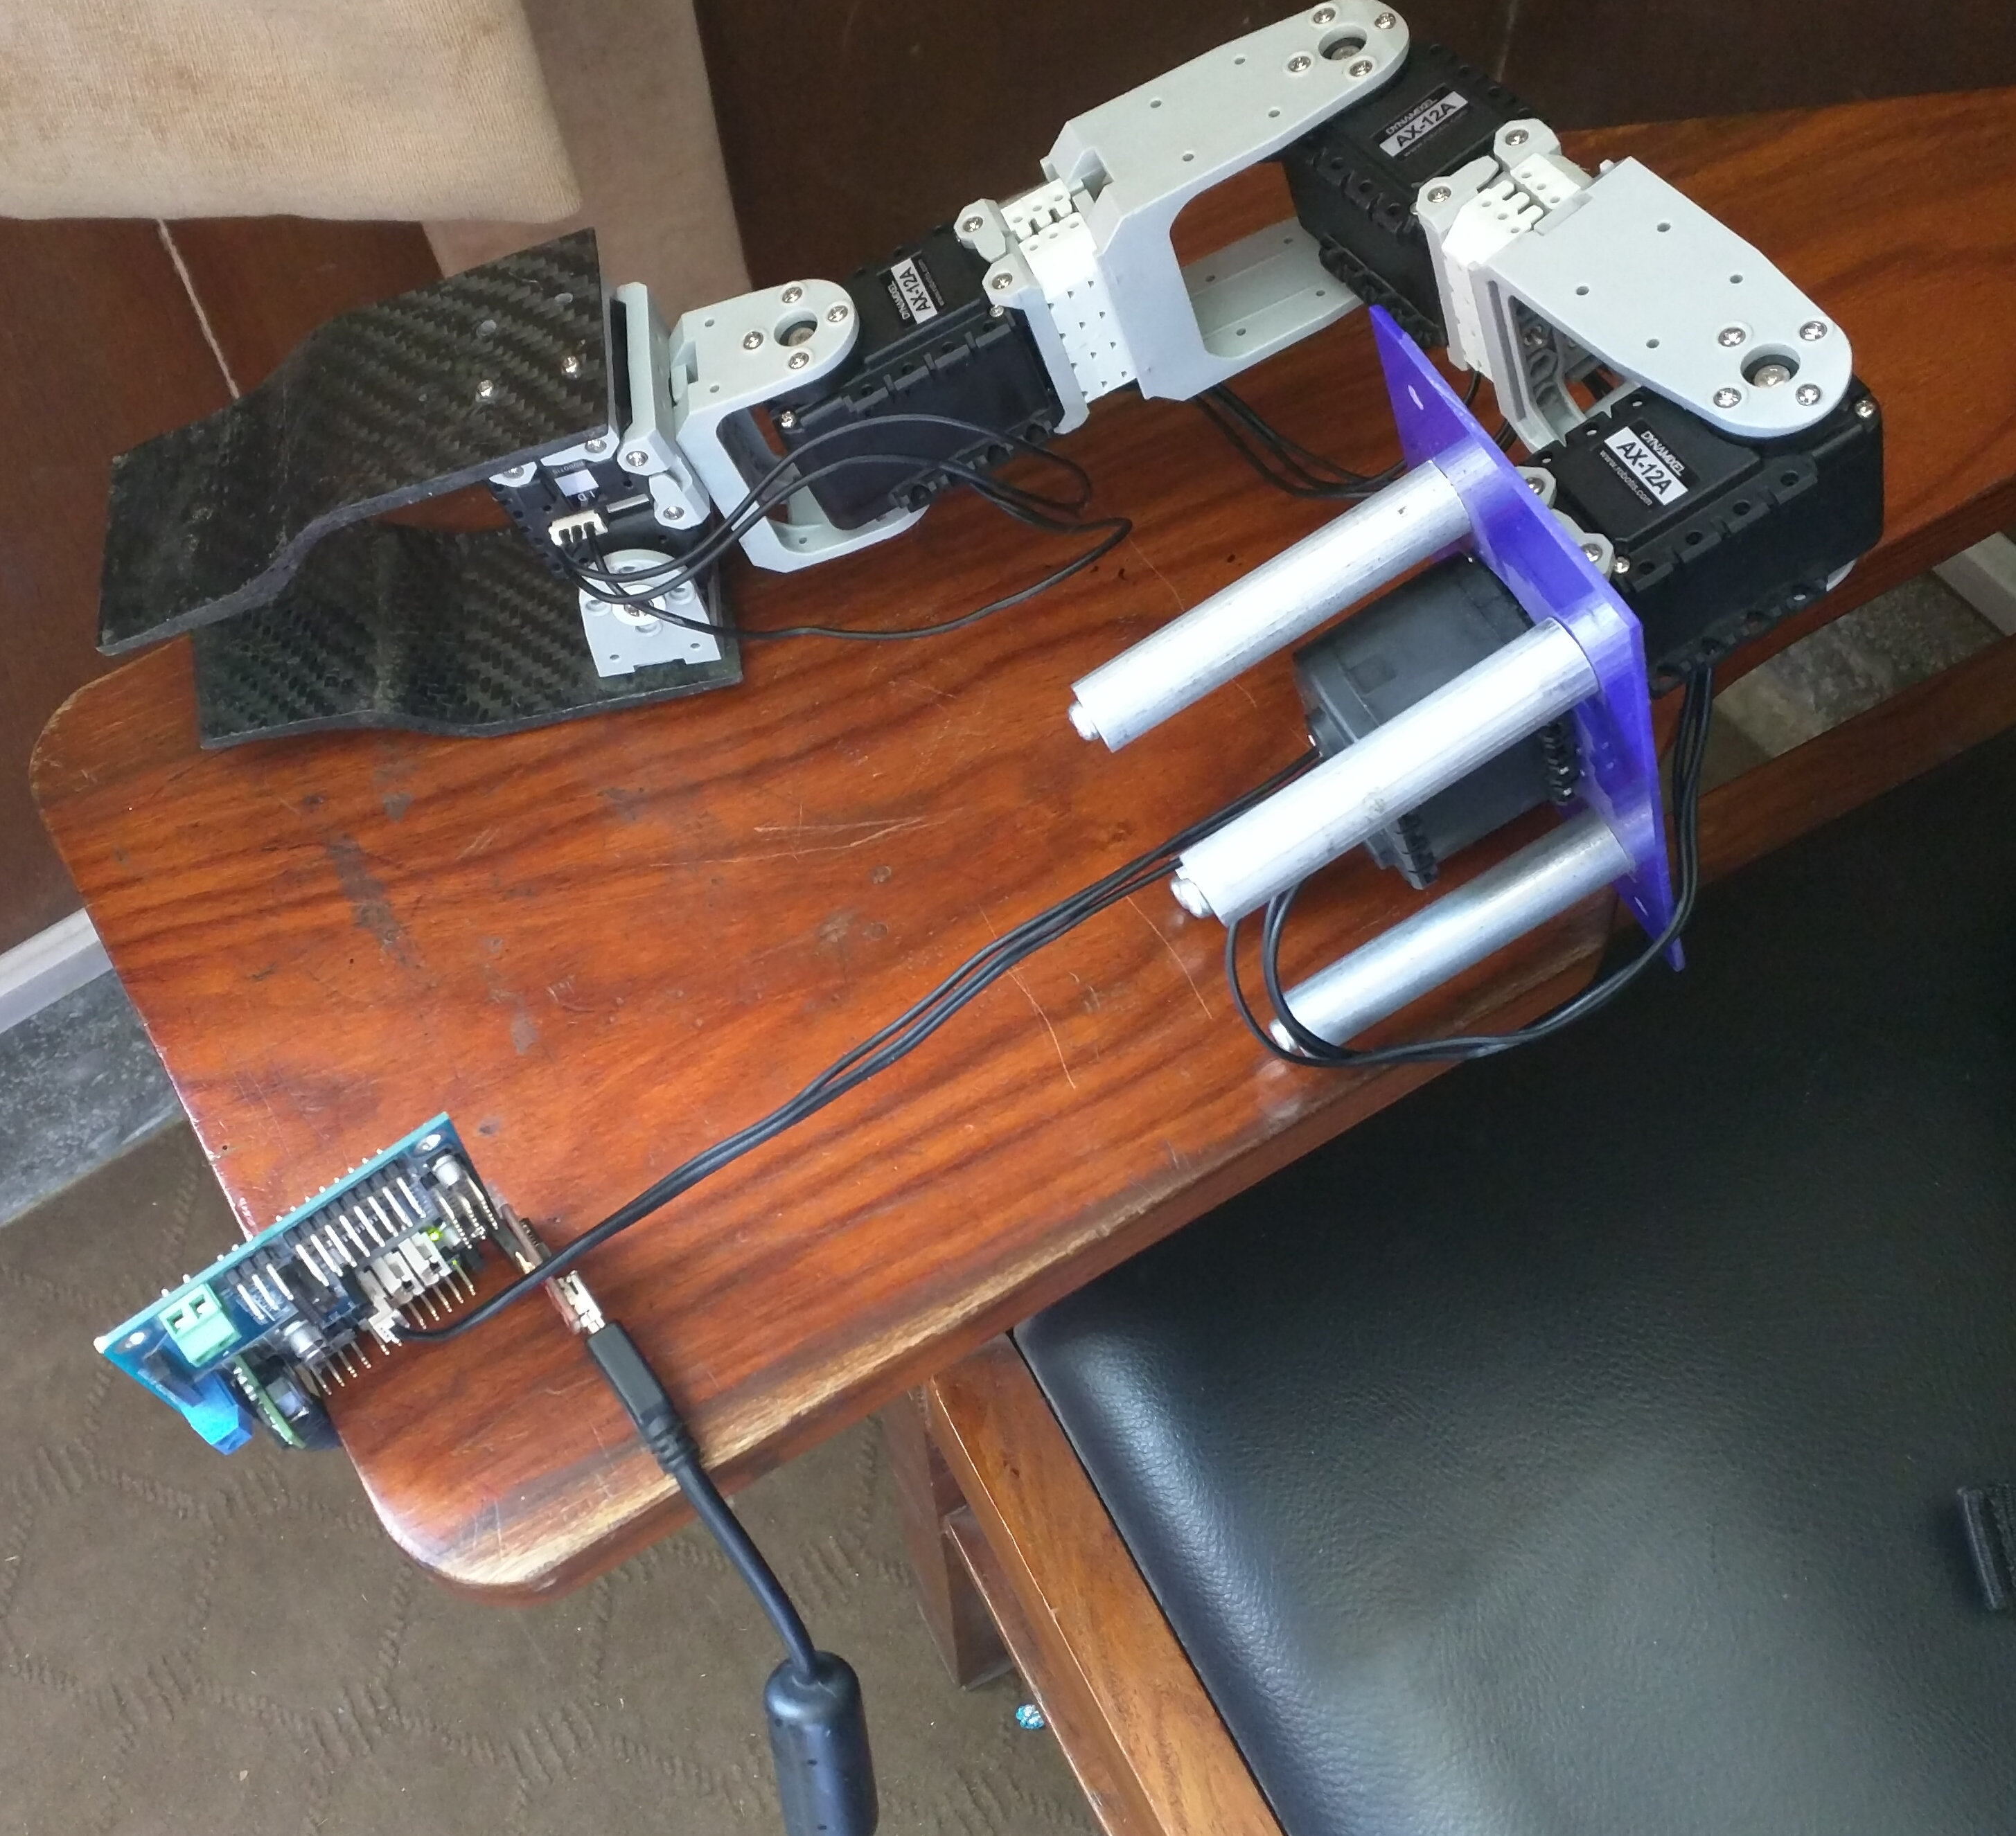

- Installed PyPose and configured the manipulator with this software. However there are a lot of problems with it. It does not list the motors on the terminal which is why it is not possible to give the IDs to the respective joints, i.e. Shoulder joint, elbow joint and wrist joint. Right now working the GUI on hit and trial basis. The servo motors move.
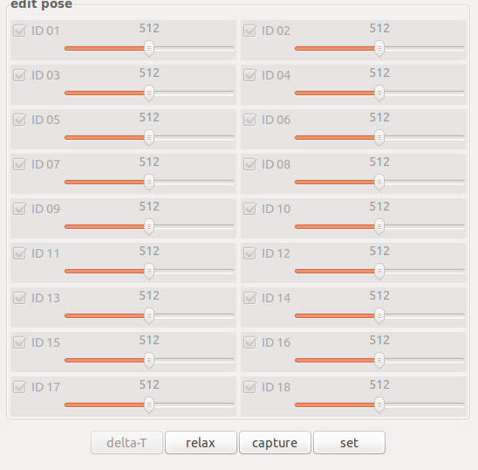
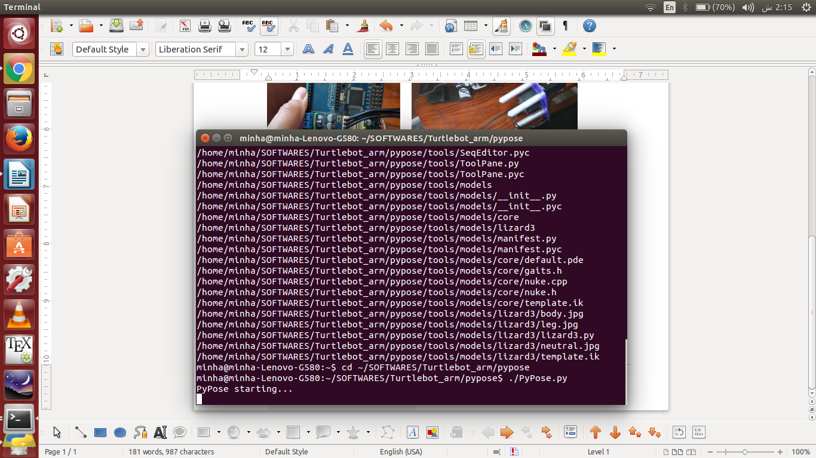

ERRORS FACED
(Minha)

The pypose doest show any ports when I connect the FDTI cable. Even though my cable drivers are installed and it is detected when I otherwise check.

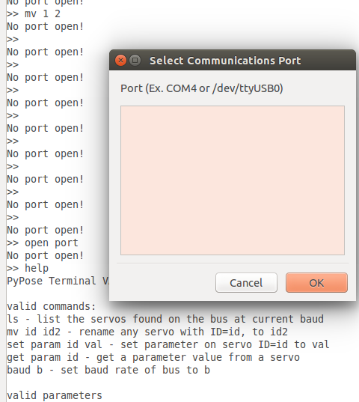

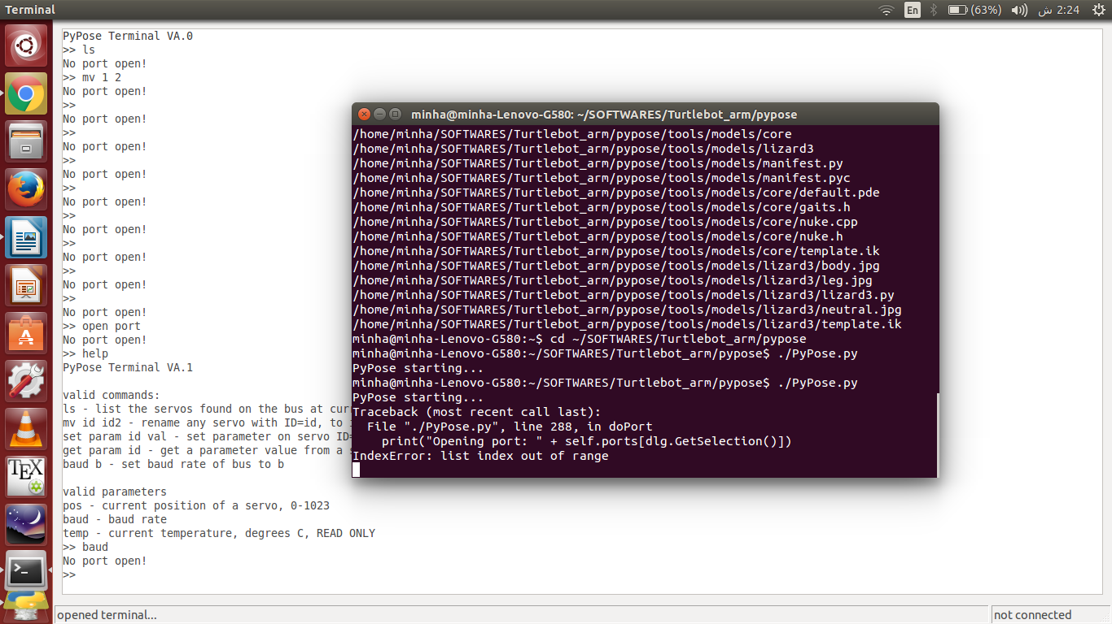
The terminal shows opening of ports but no ports are actually shows in the pypose

My PC doesnt detect the mic of KINECT, even tho when I list it on the terminal it seperately lists it.

